**3.2** **System Architecture**

After determining the requirements of the system, we will describe its major Components, their relationships (structures), and how they interact with each other.

The user can scan his skin disease with his mobile camera or upload photo from his gallery , then the system make analysis , asks the user some questions and display the result.

The user can read detailed description to understand more about his result.

After reading description, the system chooses the suitable medicine for user based on his result , then, the user can get his medicine online and contact the nearest doctor based on the user’s location.

Our system also provides a search for any skin disease and a history of disease images that the user has scanned.

**3.3 Development Methodology**

After we knew the basic structure of the system. We are going to view all of its functions, the relation between them and the sequence of their executions in the following subparts.

* + 1. **Use Case Diagrams**

First, with use case diagram, we will specify the expected behavior of the system. This helps us to design the system from end user's perspective.

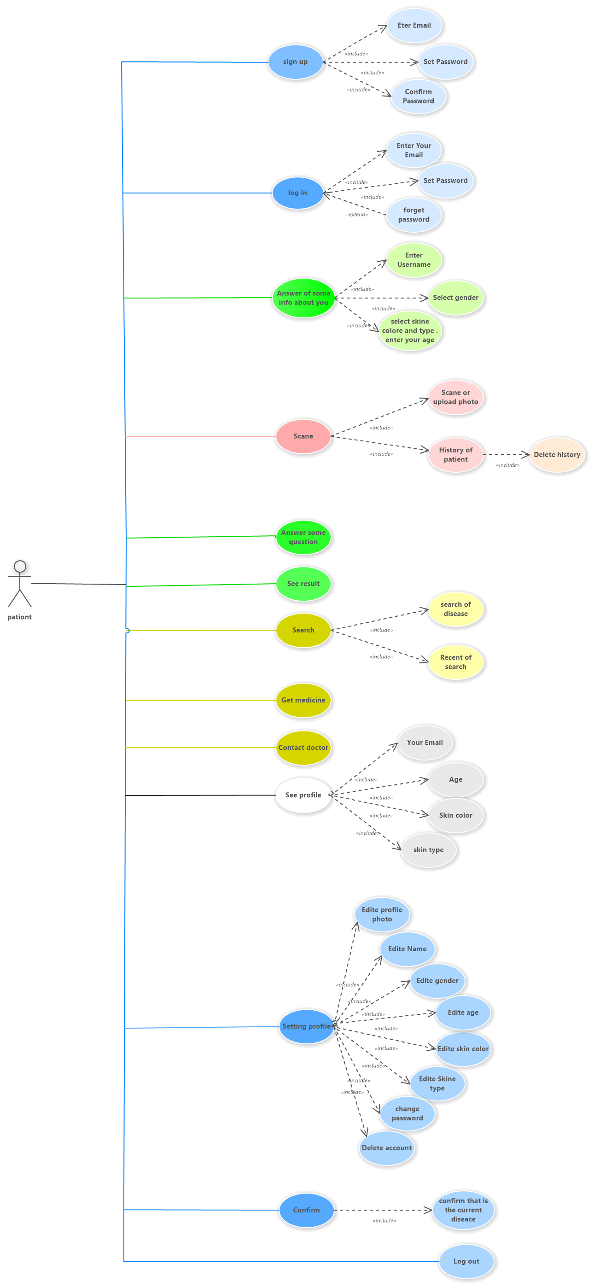

Figure 3.1: Use case diagram

* + 1. **Use Case Description**
* **Use Case : DermAI**
* **Actors : Patient**
* **Goal : jkgkj**
* **Description :**

When user scan his skin disease image , the system analyzes it after the user asks some questions about his disease and explains the result in details. The system suggests to the user the appropriate medicine , contact the nearest doctor and he can search for any disease. He can also edit his profile.

* + 1. **Sequence Diagram**

The sequence diagrams will show you how an operation is done and the inner details of it . To use our system, the user must be authorized first by sign up if it the first time or by login if he he owns an account. Once the user logged in successfully, his/her corresponding record in the database.

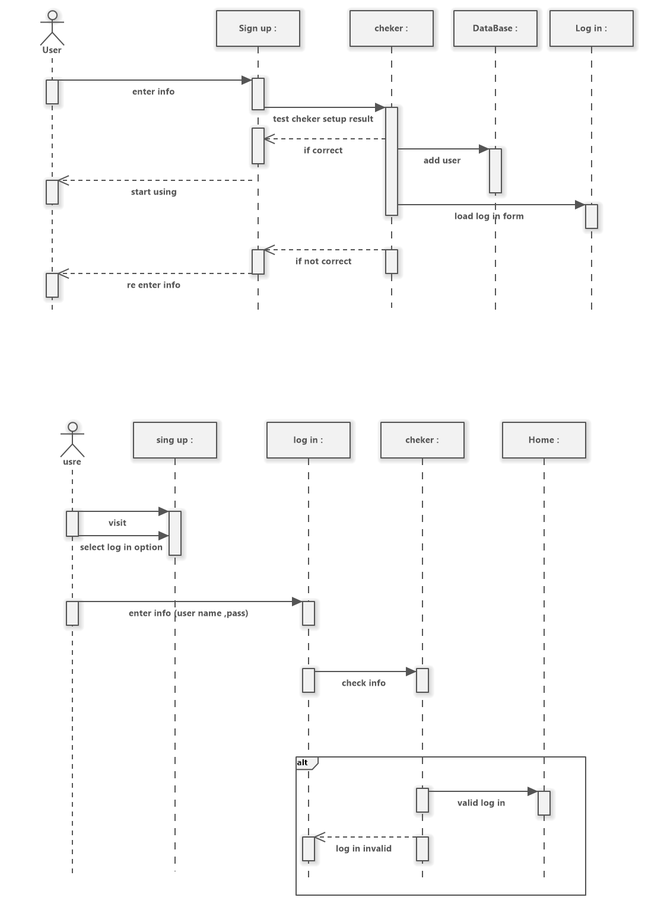

* 1. **Tools and Languages**

Developing our software application can be divided into main two parts, which are the design part, the implementation part.

The design part involves designing diagrams and designing user interface of the mobile application.

The implementation part involves programming languages, IDEs, frameworks, and libraries. The following list shows the needed tools for the software development and a brief description about their usages:

1. **Software Ideas Modeler –** it is used to draw the UML diagrams.
2. **Adobe XD –** it is used to design user interfaces and prototypes.
3. **Android Studio –** it is an IDE to build mobile application for Android OS.
4. **Postman –** it is an HTTP client that tests HTTPrequests.
5. **Visual Studio –** it is a set of development tools available in the form of visual studio add-in.
6. **PhpMyAdmin –** Open source administration tool for MySQL and MariaDB.
7. **Skipper** **–** it is a visualization tool and code/schema generator for PHP ORM framework.

**3.5 Summary**

In this chapter we provide the reader with detailed knowledge about our system. Part 3.1 include system requirements Which is divided into functional , non-functional and user requirements which specify some different specifications for users. Part 3.2 includes system architecture which describe the main components of the system, their relationships, and how they interact with each other. Part 3.3 include development methodology which includes UML diagrams that shows the details of how will the system work. In the end of the chapter we listed the needed tools to build the system.